Full Title (Arial Rounded MT Bold)  ¹ Organization, Address, City, Country  ² Organization, Address, City, Country | Presenting Author¹  Co-Authors²  Contact@E-mail

Abstract (Calibri 11)

ONE page abstract format: including figures and references.

Please follow the model below.

References

- Authors, Journal, Issue (Year) page
- Authors, Journal, Issue (Year) page
- Authors, Journal, Issue (Year) page
- Authors, Journal, Issue (Year) page

Figures

Figure 1. Calibri 10

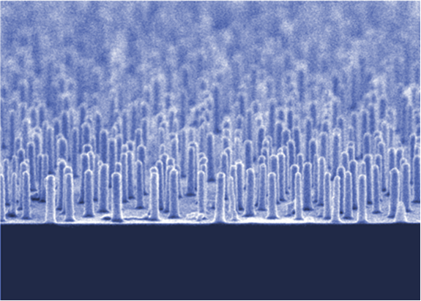

Figure 2. Calibri 10

